Hex Tiles (press molds)  Art 140: Ceramics Mr. Kaplan | 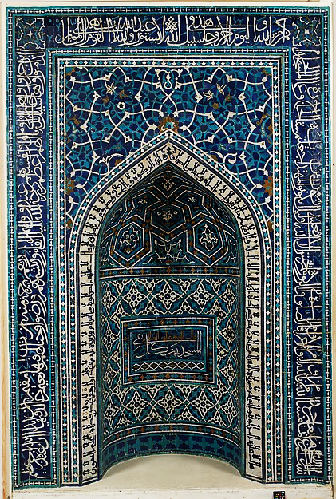  Tiles from the Mihrab of the Great Mosque of Isfahan  Originally in Isfahan, Iran.  Currently in the Metropolitan Museum of Art, NY
Tiles can be mass produced using a simple press mold. You will create an original tile in a pre-determined shape, but you must avoid undercuts or your mold will not work.

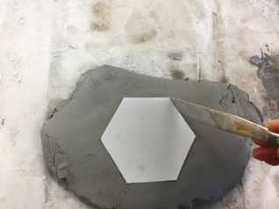 | this side bevels in and won’t work this side bevels out just a hair and will produce a successful mold
Create an even slab that is 1/2 inch thick.  Place a hexagon template on top and cut out the shape. You can also use a hexagon-shaped cutter. | Make sure you have at angle slightly greater than 91º angle between the table and the side of your hexagon. It must not bevel inward.
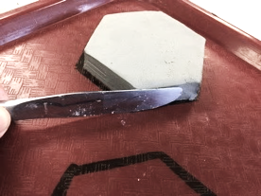 | 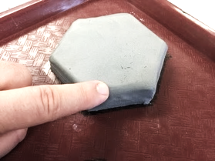
Place your blank hexagon on the tray inside the outline or in a single-tile pan. This is a good time to make sure your sides are still slightly greater than 90º. | Your top edges should not bow out either. It’s Okay if they are rounded, but they can’t be pinched outward.
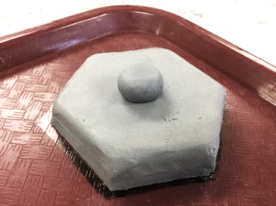 | 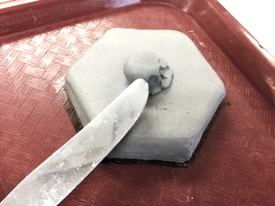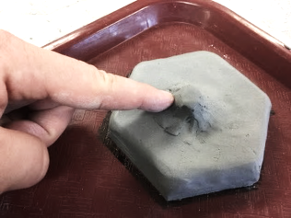
You can work additively to create your design. Avoid undercuts like this. The flattened sphere goes inward and creates an unwanted undercut. | To eliminate the undercut, blend the bottom of the shape so it flows outward where it meets the tile.
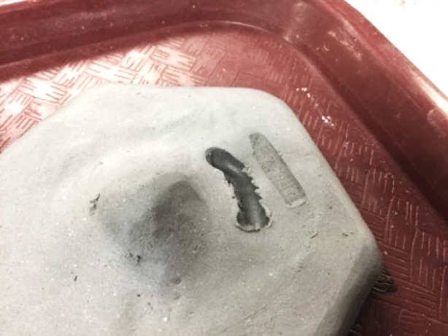 | 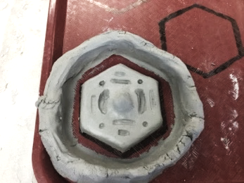 | ~OR~ | 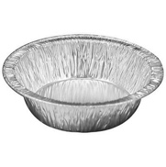  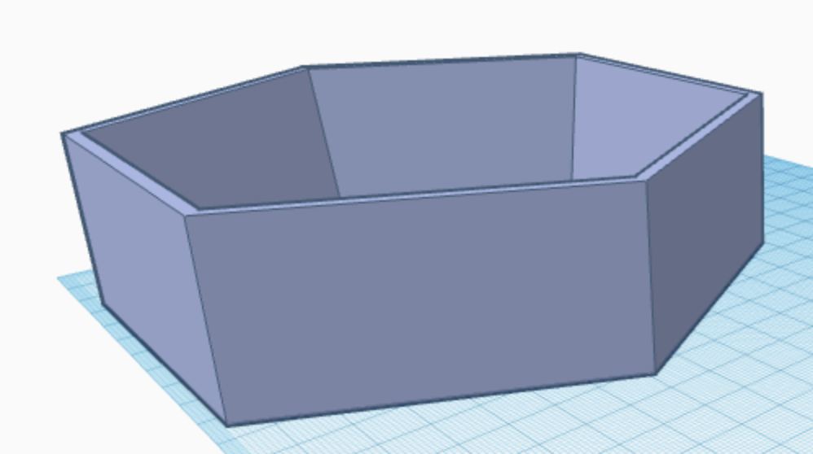
You can work subtractively, but still need to avoid undercuts. The channel on the left has a ridge blocking access to its lower parts. The top of the opening needs widened. The channel on the right is free of undercuts. | If it’s on a tray, build a clay reservoir around your tile. Ensure a finger’s width between the tile and the border, and that the reservoir is at least ½ an inch above the tile’s highest point. Your reservoir may share walls with the reservoirs of the other tiles on your tray. Add a thin coat of mold release like murphy’s oil soap. |  |  | If your tile is inside a pan or tray, add a coat of Vaseline or similar to any visible parts of the pan/tray including the walls and floor.

Again, you will need to make sure your project is free from UNDERCUTS
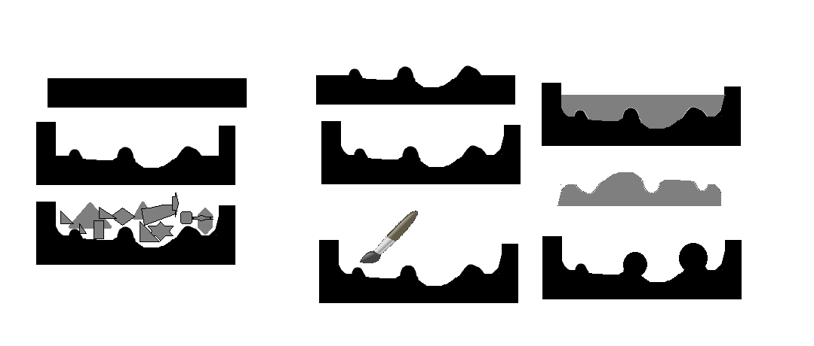
☹The cross-section of this form has undercuts☹ | ☺The cross-section of this form is free of undercuts☺

NAME__________________________________________________________ |  |  | Check One 
 |  |  | Monday+Wednesday | Tuesday+Thursday
03 Hex Tiles |  |  | ❐ 8:00-10:30 | ❐ 8:00-10:30
 |  |  | ❐ 11:00- 1:30 | ❐ 11:00- 1:30
 |  |  | ❐ 2:00- 4:30
 |  |  | ❐ 5:00- 7:30 | ❐ 5:00- 7:30
Craftsmanship | ON TARGET 5pts  My mold is essentially functional. My positives are well finished with only slight marks left from the casting process | EXCELLENT 10pts  My mold is highly functional.  My positives are expertly finished and refined. Absolutely no marks are left from the casting process.
Radial Symmetry | ON TARGET 5pts  Radial Symmetry is fairly consistent with only 1 or 2 minor deviations. | EXCELLENT 10pts  Radial Symmetry is entirely consistent with no noticeable deviations.
Checklist | I completed at least three functional positives. |  |  | ❐ 5pt
 | I roughed up the back of 2 of my tiles to help them adhere to a surface for a mosaic. |  |  | ❐ 5pt
 | I smoothed the back of 1 of my tiles and removed any burrs and/or rough spots. |  |  | ❐ 5pt
Written  Critique | Write a minimum of 1 well developed paragraph with five or more sentences. |  |  | ❐ 5pt
 | In your writing, describe your tiles to someone who couldn’t see or touch them |  |  | ❐ 5pt
 | In your writing, pick what shape would you make your tile if you weren’t limited to a hexagon |  |  | ❐ 5pt
Total |  |  | _____/50pts

