 | NAME__________________________________________________________ |  |  | Check One 
 |  |  |  | Monday+Wednesday |  | Tuesday+Thursday
 |  |  |  | ❐ 8:00-10:30 |  | ❐ 8:00-10:30
 | 08 Extruder Die 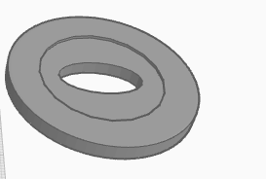 |  |  | ❐ 11:00- 1:30 |  | ❐ 11:00- 1:30
 |  |  |  | ❐ 2:00- 4:30
 |  |  |  | ❐ 5:00- 7:30 |  | ❐ 5:00- 7:30
Visual Design &  Ergonomics |  | ON TARGET 5pts  Die is functional. Shape is developed beyond a single geometric form. Resulting handles are comfortable to hold. | EXCELLENT 10pts  Die is highly functional. Shape is unique and memorable. Resulting handles are both interactive and inviting to hold without being distracting.
Checklist |  | My cutout fits inside the prescribed area of my die |  |  |  |  | ❐ 5pt
 |  | While a cut out was added, the outside dimensions of my die were not changed |  |  |  |  | ❐ 5pt
 |  | My initials were included in my die’s design |  |  |  |  | ❐ 15pt
Written  Critique |  | Write a minimum of 1 well developed paragraph with five or more sentences. |  |  |  |  | ❐ 5pt
 |  | In your writing, elaborate on how you balanced the visual and tactile appeal of your handle |  |  |  |  | ❐ 5pt
 |  | In your writing, explain any changes you might make if you were to re-do your design. |  |  |  |  | ❐ 5pt
Total |  |  |  |  | _______/50pts

